AI-BASED CAMPUS ENERGY CONSUMPTION\nAND ANOMALY DETECTION SYSTEM
Research Article / Main Project Report

A machine-learning system for estimating expected building energy use, forecasting temporal patterns, and identifying unusual consumption

Project: Campus Energy & Anomaly System\nInstitutional context shown in prototype: Coimbatore Institute of Technology (CIT), Coimbatore

ABSTRACT
Campus buildings consume electricity across classrooms, laboratories, libraries, administrative blocks, and shared facilities. Because energy demand changes with occupancy, schedules, environmental conditions, and equipment usage, a high meter reading is not automatically evidence of waste. This project develops a campus-oriented decision-support prototype that estimates expected energy consumption and highlights readings that differ from learned patterns. A synthetic dataset created for this project contains 6,480 records. The data is divided into training, validation, and test subsets using a 70:10:20 split. Random Forest Regression is used to estimate expected consumption from tabular features, an LSTM (Long Short-Term Memory) network is used to model temporal sequences, and Isolation Forest is used for unsupervised anomaly detection. The application connects these models to a dashboard with building registration, energy-entry forms, prediction history, anomaly investigation, recommendations, model-performance summaries, and threshold settings. The supplied interface screenshots show eight monitored facilities, 6,501 displayed hourly readings in the overview, and model metrics for both Random Forest and LSTM. Some figures differ between dashboard summary cards and detailed model cards, and the overview and anomaly centre also show different anomaly counts. These differences are documented rather than silently reconciled. The prototype demonstrates an integrated workflow for monitoring, prediction, and investigation; real-world generalisation and operational energy savings would require evaluation on representative real meter data and verification of the displayed metrics.
Keywords: campus energy, synthetic dataset, Random Forest Regression, LSTM, Isolation Forest, anomaly detection

1. INTRODUCTION
Energy management is an everyday operational challenge for large educational campuses. Different buildings have different operating hours, occupancy levels, equipment, and cooling requirements. A library may remain active into the evening, while a lecture hall may be busy only during scheduled classes. Looking at raw readings alone makes it difficult to decide whether a value is expected for that building and time or deserves investigation.
This project addresses that challenge by combining prediction, time-series modelling, anomaly detection, and a dashboard. Random Forest estimates expected energy use from structured features. LSTM processes sequences to learn temporal patterns. Isolation Forest provides a separate unsupervised signal for observations that look unusual compared with the data distribution. The interface presents readings, predictions, deviations, severity, and recommended follow-up actions in a single workflow.
The project is a prototype built and evaluated using a synthetic dataset. This is useful for controlled development and repeatable testing, but it is not equivalent to validation on real campus smart-meter data. The report therefore distinguishes the results visible in the supplied application screenshots from claims that would require further testing.

1.1 Objectives
- Create a synthetic energy dataset containing 6,480 records for model development and testing.
- Use a 70% training, 10% validation, and 20% test split.
- Estimate expected energy consumption using Random Forest Regression.
- Model sequential or time-dependent energy patterns using LSTM.
- Identify unusual records using Isolation Forest and deviation-based evidence.
- Provide a dashboard for building information, data entry, prediction history, anomaly review, recommendations, and model performance.

1.2 Main Contribution
The main contribution is the integration of three complementary model functions with a campus-oriented interface: tabular regression for expected values, sequence learning for temporal patterns, and unsupervised anomaly detection for investigation. The interface also links alerts with building context and operational recommendations so users can move from a chart or warning to a possible follow-up action.

2. RELATED WORK / LITERATURE REVIEW
Research on building energy analytics has explored regression, deep learning, time-series modelling, and anomaly detection. Reviews published between 2020 and 2022 describe the growing use of machine learning and deep learning for building-energy forecasting, while studies from 2023 onward examine more specialised anomaly-detection methods and temporal representations. The following studies provide context for the choices made in this prototype; their reported results should not be compared numerically with this project unless the datasets and evaluation procedures are comparable.
Xu and Chen [1] examined a hybrid data-mining approach for energy anomaly detection. Himeur et al. [2] reviewed AI-based building-energy anomaly detection and identified broader research directions. Reviews by Khalil et al. [3], Ardabili et al. [4], and other authors [5], [6] discuss the range of statistical, machine-learning, and deep-learning approaches used for energy prediction. More recent work considers dedicated anomaly frameworks [7], dynamic detection methods [8], time-series image representations [9], multivariate temporal models [10], and hybrid forecasting architectures [11].
These studies support the general motivation for combining prediction and anomaly analysis. The current project differs in scope: it focuses on a working campus dashboard and a synthetic dataset for controlled prototype evaluation. Its results should be treated as implementation evidence, not as a claim that the model outperforms the published methods.

3. PROBLEM DEFINITION AND OBJECTIVES
Given a record describing a building, a timestamp, energy consumption, and available contextual variables, the system aims to estimate expected consumption and identify records that depart from typical patterns. The primary users are campus facilities staff, energy managers, and administrators who need to inspect building-level energy trends and prioritise readings for review.
Element | Description
Input | Synthetic meter records with energy and contextual/time-related features; the application also provides manual energy-entry fields.
Prediction output | Expected energy consumption from Random Forest Regression and temporal estimates from the LSTM sequence model.
Anomaly output | Isolation Forest flags and/or deviation-based indicators for observations that differ from expected or common patterns.
Decision-support output | Building-wise charts, prediction logs, severity indicators, investigation details, recommendations, and threshold configuration.
Task types | Regression, time-series sequence modelling, and unsupervised anomaly detection.

3.1 Research Questions
- Can a Random Forest model learn useful relationships between the synthetic tabular features and energy consumption?
- Can an LSTM model represent temporal patterns in a sliding sequence of readings?
- Can Isolation Forest provide an additional signal for identifying unusual records?
- Can a dashboard make model outputs easier to inspect and translate into follow-up actions?

4. DATASET DESCRIPTION
The project uses a synthetic dataset created for this implementation; it is not a dataset downloaded from BDG2 or ASHRAE. The dataset contains 6,480 records and was created to provide patterned observations for training and testing the prediction and anomaly-detection pipeline. Because the records are synthetic, they support controlled development but cannot by themselves establish how well the system will generalise to actual campus meters.
Dataset property | Project detail
Dataset origin | Synthetic data generated for this project.
Number of records | 6,480 records, as specified by the project developer.
Split | 70% training, 10% validation, 20% test.
Approximate split counts | 4,536 training; 648 validation; 1,296 test records, assuming a direct row-wise split.
Target | Energy consumption, represented in the interface in kWh.
Context visible in application | Building, timestamp, meter interval, outdoor/indoor temperature, relative humidity, occupancy, day type, operating status, HVAC runtime status, tariff, and observation notes.
Labeling | The data is synthetic. Exact generation rules and ground-truth anomaly-label distribution were not supplied in the screenshots.
Limitations | Synthetic patterns may be simpler or more regular than real meter data; external validation is still required.

The split counts above are the arithmetic implied by the stated proportions and 6,480 total records. The report does not assume a particular random seed or split strategy because those implementation details were not shown. For time-series evaluation, a chronological split is generally preferable when the intended use is to predict future periods; the final code should be checked to confirm whether the current split preserves time order.

4.1 Feature and Input Fields
The energy-entry screen exposes primary meter details (building, timestamp, energy consumed, and meter interval), environmental context (outdoor temperature, indoor temperature, relative humidity, and occupancy), and operational/financial context (day type, operating status, HVAC runtime status, and tariff rate). These are the fields visible in the interface; the precise subset passed to each model should be confirmed against the preprocessing code.

4.2 Data Quality and Synthetic-Data Limitations
A complete reproducible experiment should document how missing values, duplicated timestamps, invalid or negative readings, and outliers are handled. It should also state whether generated anomaly cases have explicit labels and how those labels are created. The screenshots do not establish these details, so they are not claimed as completed steps here.

5. METHODOLOGY
The implementation follows a sequence from data preparation to prediction, anomaly analysis, and dashboard presentation. The models serve different purposes and are not interchangeable: Random Forest handles tabular regression, LSTM handles ordered sequences, and Isolation Forest looks for observations that are unusual in feature space.

5.1 Data Preprocessing and Feature Preparation
- Load the generated records and validate the expected columns and data types.
- Parse timestamps and prepare temporal fields or sequence windows where required by the model.
- Prepare input features and the energy-consumption target, ensuring the target is not accidentally included as an input.
- Split the records into training, validation, and test subsets using the project’s 70:10:20 configuration.
- Fit data-dependent transformations on the training set only, then apply the same transformations to validation and test data.

5.2 Random Forest Regression
Random Forest Regression is used as the main tabular prediction model. It builds an ensemble of decision trees and combines their outputs to estimate expected energy consumption. This approach can capture nonlinear relationships between variables such as time, occupancy, building characteristics, and energy use without requiring a single linear relationship.
The model-performance screenshot identifies the active baseline as Random Forest and shows a model card named RandomForestRegressor v1.0 with 120 estimators, maximum depth 16, and 24 engineered features. The card reports MAE 2.25 kWh, RMSE 3.82 kWh, and R² 0.9720. The summary cards above it show R² 0.9754 and MAE 2.214 kWh. These are both transcribed from the interface; because the values differ, the final report should use one verified evaluation output after the implementation is checked.

5.3 LSTM Time-Series Model
LSTM stands for Long Short-Term Memory. It is a recurrent neural network architecture designed to learn relationships across ordered sequences. In this project, the LSTM is used for time-series calculation and sequence-based energy estimation. The model card describes a 24-hour sliding sequence, hidden dimension 32, and BPTT with Adam; the summary indicates training over 25 epochs.
The model card reports MAE 0.17 kWh, RMSE 0.27 kWh, and R² 0.9304. The summary cards report R² 0.928 and MAE 0.19 kWh. The screenshot also shows a training duration of 9.54 seconds. Since summary and detail values do not exactly match, they are documented as displayed rather than presented as a single reconciled score.

5.4 Isolation Forest Anomaly Detection
Isolation Forest is an unsupervised algorithm that identifies observations that are relatively easy to isolate through random feature partitioning. It can flag unusual combinations of energy, time, occupancy, or environmental context without requiring every anomaly type to be labelled in advance. Its output is an indicator for investigation, not proof of a fault.
The interface includes an anomaly centre with severity, lifecycle status, detection method, actual energy, expected baseline, residual deviation, percentage deviation, explanatory text, and a suggested action. The settings screen shows a warning threshold of 20% and a critical threshold of 40%. These thresholds are user-configurable in the interface. The exact Isolation Forest parameter values and the precise way its flags are combined with residual thresholds should be confirmed from the source code.

5.5 Residual Analysis and Severity
For a measured value y and prediction ŷ, the residual is r = y − ŷ. A positive residual means measured consumption is higher than expected; a negative residual means it is lower. The percentage deviation can be expressed as 100 × (y − ŷ) / ŷ when ŷ is non-zero. Threshold-based severity can then help prioritise review. The application shows warning and critical thresholds of 20% and 40%, respectively; the precise boundary convention should be checked in the implementation.

5.6 Dashboard and API Modules
Module | Purpose shown in the prototype
Overview | Campus-level energy totals, estimated cost, active anomaly summary, monitored facilities, actual-versus-expected chart, and diurnal profile.
Buildings Registry | Register and search buildings, view floor area, occupancy capacity, operating hours, HVAC status, and meter IDs.
Energy Data & Entry | Enter readings and contextual variables manually, and explore searchable historical records.
Predictions | View inference history with actual and predicted kWh, residual, deviation percentage, and model version.
Anomaly Center | Filter anomaly events by severity, lifecycle status, and detection method; inspect explanations and investigation status.
Recommendations | Show actionable directives, supporting evidence, verification checklists, assigned campus roles, and estimated savings.
Model Performance | Compare Random Forest and LSTM metrics, feature importance, model configuration, and training/inference timing.
Settings | Configure residual-based warning and critical thresholds.
Backend API | The architecture diagram shows a FastAPI application with separate routes for prediction, anomalies, buildings, overview, analytics, telemetry explorer, pipeline control, and model metrics.
Persistence | The architecture diagram shows database sessions, energy records/model data, and runtime settings.

5.7 Proposed Innovation / Application Component
The application contribution is not a new learning algorithm; it is the workflow that connects model output to operational context. A user can select a building, inspect readings, view expected consumption, review a flagged event, read the available explanation, and track a recommendation through a lifecycle status. This structure makes the output more actionable than a prediction value alone, while still requiring human judgement for final decisions.

6. EXPERIMENTAL SETUP
Item | Details available from the project materials
Dataset size | 6,480 synthetic records.
Data split | 70% train / 10% validation / 20% test.
Random Forest | 120 estimators; maximum depth 16; 24 engineered features, as shown on the model card.
LSTM | 24-hour sliding sequence; hidden dimension 32; BPTT with Adam; 25 epochs shown.
Isolation Forest | Used for anomaly detection; exact hyperparameters are not visible in the screenshots.
Reported RF inference latency | 0.08 ms for a single observation, as shown in the model-performance summary.
Reported LSTM training duration | 9.54 seconds, as shown in the model-performance summary.
Application stack shown in footer | FastAPI, PyTorch/Scikit-learn, and React.
Hardware / software versions / random seed | Not established by the screenshots; these should be recorded from the actual development environment.

The dashboard overview reports 6,501 hourly meter readings, while the dataset description supplied by the developer states that the synthetic dataset has 6,480 records. These values may refer to different application counts or a different state of the data. The report preserves both displayed figures and recommends confirming the count directly from the dataset and API before final submission.

7. EVALUATION METRICS
Regression metrics summarise how close predicted consumption is to the measured target. They should be computed on the held-out test set and with consistent units.
Mean Absolute Error (MAE): MAE = (1/n) Σ |yᵢ − ŷᵢ|. It represents the average absolute prediction error in the target unit.
Root Mean Squared Error (RMSE): RMSE = √[(1/n) Σ (yᵢ − ŷᵢ)²]. It gives greater weight to larger errors.
Coefficient of determination (R²): R² = 1 − [Σ(yᵢ − ŷᵢ)² / Σ(yᵢ − ȳ)²]. It compares prediction error with a mean-based reference.
Inference latency measures the time taken to generate a prediction for an input. Training duration records the time used to fit a model under a particular environment. For anomaly detection, useful reporting includes the number of flagged records, the proportion flagged, examples of alerts, and review findings. Precision, recall, F1-score, and a confusion matrix should only be reported if reliable ground-truth anomaly labels are available.

8. RESULTS
The following values are transcribed from the supplied application screenshots. They demonstrate that the interface contains model outputs and dashboard summaries, but should be treated as displayed prototype results until the underlying evaluation logs confirm that they were computed from the same held-out test set.
Model / dashboard item | Metric shown | Value shown
Random Forest summary card | R² | 0.9754
Random Forest summary card | MAE | 2.214 kWh
RandomForestRegressor v1.0 model card | MAE | 2.25 kWh
RandomForestRegressor v1.0 model card | RMSE | 3.82 kWh
RandomForestRegressor v1.0 model card | R² | 0.9720
Random Forest inference | Latency | 0.08 ms
LSTM summary card | R² | 0.928
LSTM summary card | MAE | 0.19 kWh
LSTM Sequence Regressor v1.0 model card | MAE | 0.17 kWh
LSTM Sequence Regressor v1.0 model card | RMSE | 0.27 kWh
LSTM Sequence Regressor v1.0 model card | R² | 0.9304
LSTM training | Duration | 9.54 seconds; 25 epochs shown

8.1 Dashboard-Level Values
Dashboard indicator | Value shown in screenshots | Interpretation
Monitored facilities | 8 | Eight campus facilities/blocks are listed as monitored.
Overview total energy | 247,755.1 kWh | Campus-level aggregate displayed by the overview.
Overview estimated cost | ₹1,858,164 | Cost estimate displayed by the overview; tariff and aggregation logic should be verified.
Overview active anomalies | 150 | Top-level summary count.
Anomaly centre total flagged | 136 | A different count appears in the anomaly-centre view.
Anomaly centre critical severity | 14 | Events shown under the critical-severity summary.
Dual-method confirmed | 10 | Count displayed for events where methods agree.
Active investigations | 15 | Open or under-review cases displayed.
Recommendation workspace | ~70 kWh; ₹524 | Potential energy recovery and cost-reduction estimate displayed.
Warning / critical thresholds | 20% / 40% | Configurable residual-based thresholds shown in Settings.

The screenshots show an example anomaly where observed energy is 72.5 kWh against an expected baseline of 20.1 kWh, with a displayed residual of +52.4 kWh and percentage deviation of +261.4%. The explanation suggests checking HVAC, server-lab cooling, or lighting that may have remained active outside normal hours. This is an example of the system’s explanatory workflow, not a verified diagnosis of the actual cause.

8.2 Results Screenshots
The screenshots below are included as evidence of the implemented interface and its displayed outputs. They are not substitutes for exported evaluation logs or a reproducible test run.
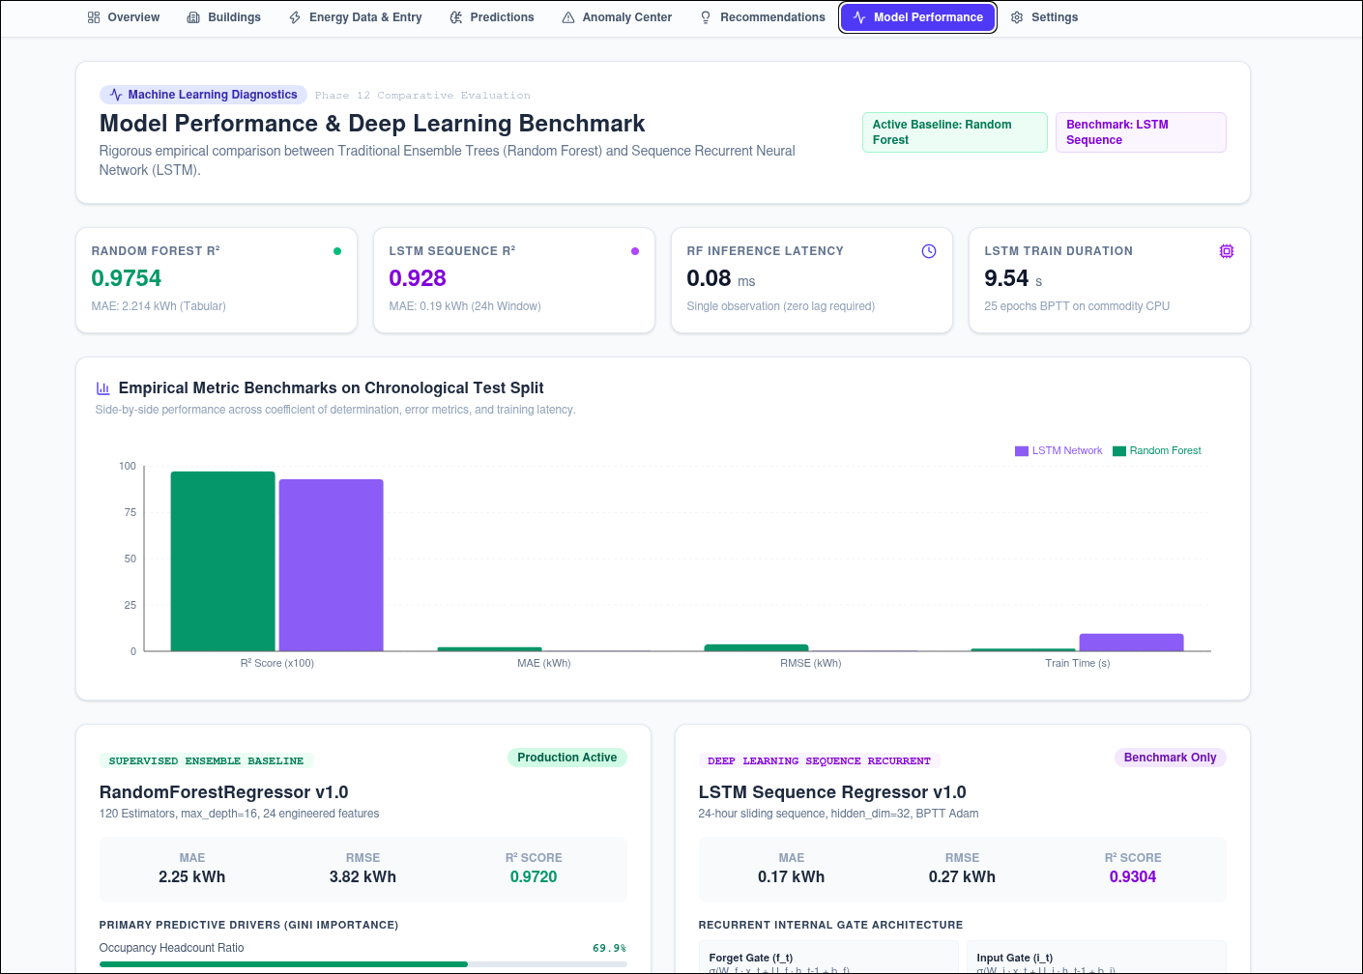
Figure 1. System architecture showing the frontend routes, FastAPI modules, energy intelligence components, and persistence layer.
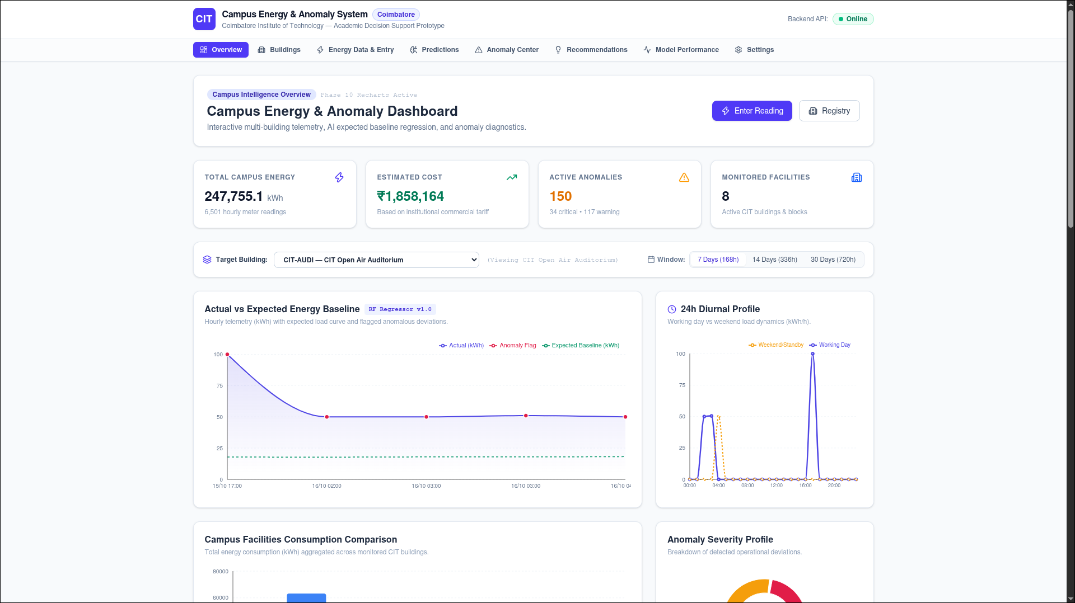
Figure 2. Campus energy overview with summary indicators, actual-versus-expected trend, and diurnal profile.

Figure 3. Building registry with building metadata, operating hours, meter identifiers, and monitoring status.
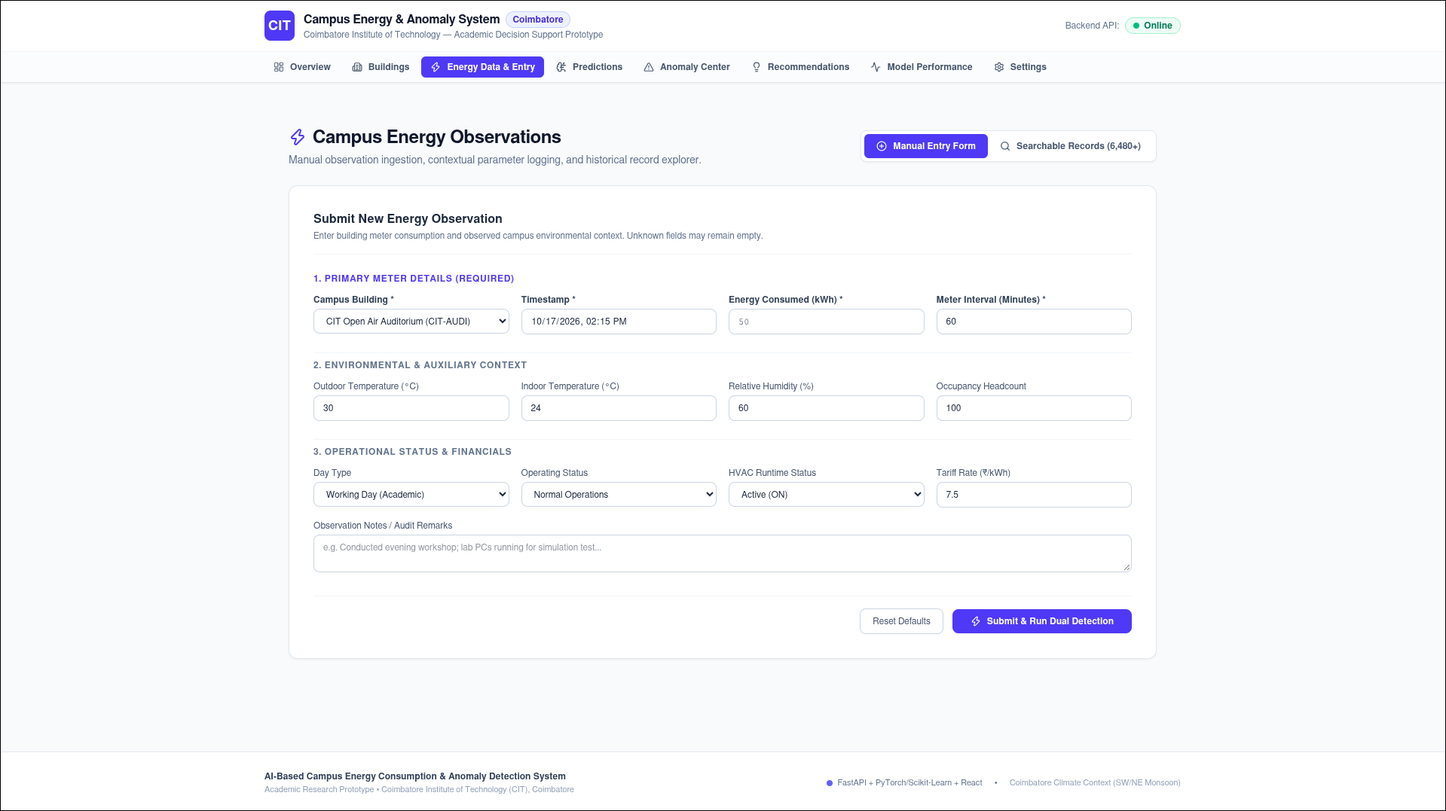
Figure 4. Energy observation form for meter readings and environmental/operational context.
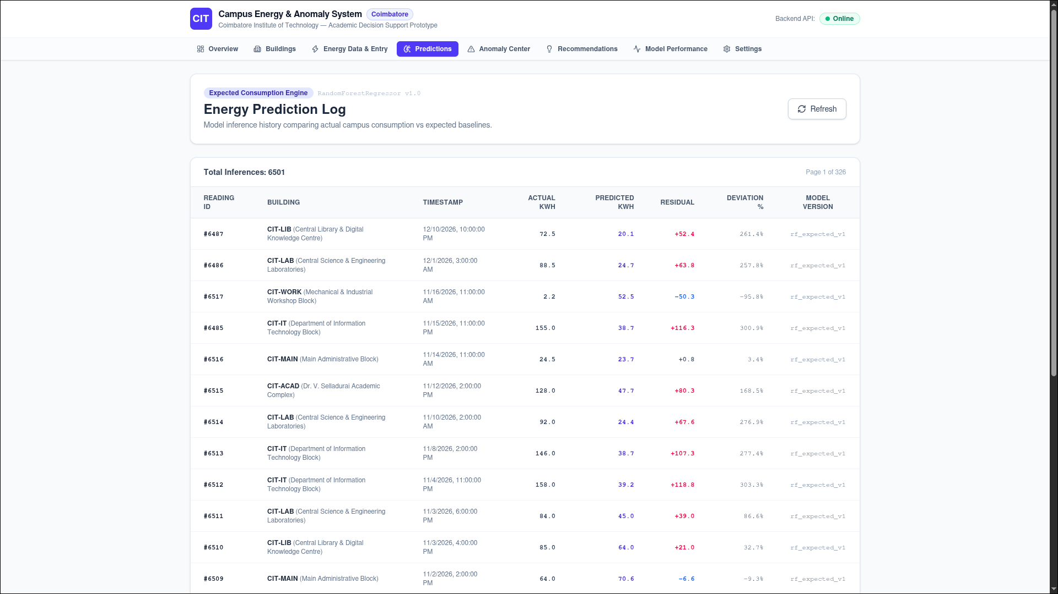
Figure 5. Energy prediction log showing actual and predicted values, residuals, percentage deviation, and model version.
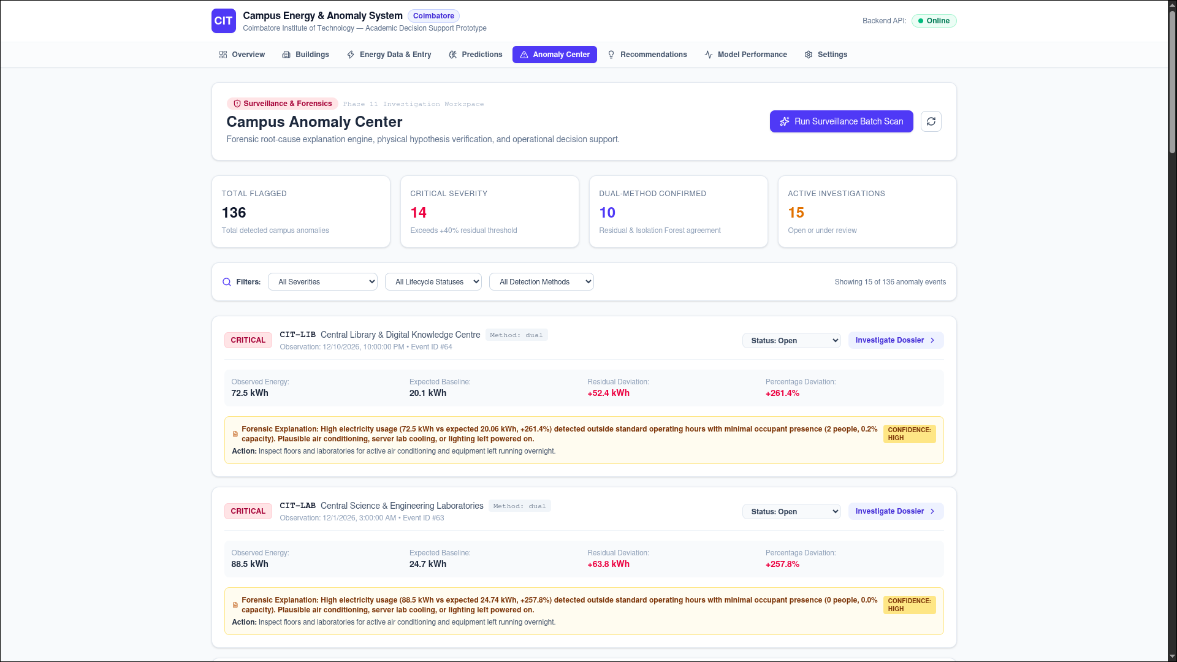
Figure 6. Anomaly investigation view with severity, residual evidence, explanation, and action guidance.

Figure 7. Operational recommendations with supporting evidence, verification checklist, role assignment, and estimated savings.
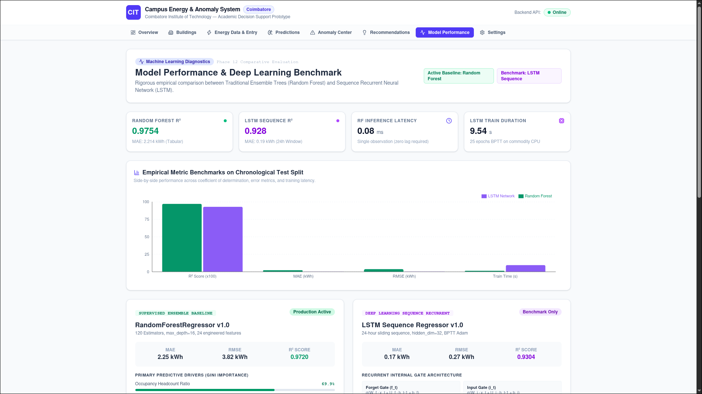
Figure 8. Model-performance comparison for Random Forest and LSTM, including reported metrics and model settings.

Figure 9. System settings showing warning and critical residual thresholds.

9. DISCUSSION
The supplied screens demonstrate a coherent end-to-end prototype: users can explore buildings, enter energy observations, review prediction history, inspect unusual events, and follow operational recommendations. Random Forest and LSTM provide complementary prediction approaches, while Isolation Forest adds an unsupervised anomaly signal. The dashboard’s emphasis on building, timestamp, actual use, expected baseline, deviation, and suggested action is useful because it gives staff context for reviewing an alert.
Several data-consistency checks should be completed before presenting the results as final. First, the Random Forest summary card and detailed model card show slightly different MAE and R² values. The LSTM summary and model card also differ. Second, the overview reports 6,501 readings while the supplied synthetic dataset is described as containing 6,480 records. Third, the overview shows 150 active anomalies while the anomaly centre shows 136 total flagged events. These counts may be drawn from different filters, timestamps, or model states, but the screenshots alone do not establish why. They should be reconciled from the API/database and final evaluation output.
The high R² values visible in the interface are encouraging as prototype outputs, but synthetic data can contain patterns that are easier to learn than real-world consumption. An appropriate next test would evaluate the models on real campus meter data across different buildings and time periods. Anomaly labels should be reviewed by domain experts where possible, and recommendation savings should be treated as estimates until actual before-and-after energy use is measured.

9.1 Limitations
- The dataset is synthetic, so performance does not yet establish real-world generalisation.
- The exact synthetic-data generation procedure and anomaly ground-truth distribution are not included in the screenshots.
- Metric differences between summary cards and model cards require reconciliation.
- Displayed record and anomaly counts are inconsistent across screens and need a single source-of-truth check.
- Hardware, software versions, random seed, and exact Isolation Forest settings are not visible in the supplied materials.
- Potential savings shown by the dashboard are estimates, not verified energy reductions.

10. CONCLUSION AND FUTURE WORK
This project presents an AI-based campus energy monitoring and anomaly-detection prototype that brings together Random Forest Regression, LSTM sequence modelling, Isolation Forest, and a multi-page dashboard. The synthetic dataset contains 6,480 records and is intended to be split 70:10:20 for training, validation, and testing. The application includes building management, energy observation entry, prediction history, anomaly investigation, recommendations, model benchmarking, and configurable thresholds.
The current screenshots show that the prototype exposes model metrics and operational summaries, but metric and count inconsistencies mean the final evaluation should be verified before making a definitive model comparison. Future work should document the synthetic-data generator, confirm the split strategy and model inputs, export test-set predictions and metric logs, reconcile dashboard counts, evaluate against real campus readings, and review alerts with facilities staff. Further improvements may include real-time smart-meter integration, robust temporal validation, explainability for model predictions, and measuring realised savings after interventions.

DATA AND CODE AVAILABILITY
The dataset used for the reported prototype is synthetic and was created by the project developer. A public download URL, licence statement, repository URL, trained-model artifact, and reproducible execution instructions were not confirmed in the supplied screenshots. Add the project repository and dataset-generation details here once they are ready to share.

REFERENCES
[1] C. Xu and H. Chen, “A hybrid data mining approach for anomaly detection and evaluation in residential buildings energy data,” Energy and Buildings, vol. 215, article 109864, 2020. https://doi.org/10.1016/j.enbuild.2020.109864
[2] Y. Himeur, K. Ghanem, A. Alsalemi, F. Bensaali, and A. Amira, “Artificial intelligence based anomaly detection of energy consumption in buildings: A review, current trends and new perspectives,” Applied Energy, vol. 287, article 116601, 2021. https://doi.org/10.1016/j.apenergy.2021.116601
[3] M. Khalil, A. S. McGough, Z. Pourmirza, M. Pazhoohesh, and S. Walker, “Machine Learning, Deep Learning and Statistical Analysis for forecasting building energy consumption—A systematic review,” Engineering Applications of Artificial Intelligence, vol. 115, article 105287, 2022. https://doi.org/10.1016/j.engappai.2022.105287
[4] S. Ardabili et al., “Systematic Review of Deep Learning and Machine Learning for Building Energy,” Frontiers in Energy Research, vol. 10, 2022. https://doi.org/10.3389/fenrg.2022.786027
[5] “Physical energy and data-driven models in building energy prediction: A review,” Energy Reports, 2022. https://doi.org/10.1016/j.egyr.2022.01.162
[6] “Machine Learning and Deep Learning Methods for Enhancing Building Energy Efficiency and Indoor Environmental Quality—A Review,” Energy and AI, vol. 10, article 100198, 2022. https://doi.org/10.1016/j.egyai.2022.100198
[7] L. Mascali et al., “A machine learning-based Anomaly Detection Framework for building electricity consumption data,” Sustainable Energy, Grids and Networks, vol. 36, article 101194, 2023. https://doi.org/10.1016/j.segan.2023.101194
[8] “A dynamic anomaly detection method of building energy consumption based on data mining technology,” Energy, vol. 263, article 125575, 2023. https://doi.org/10.1016/j.energy.2022.125575
[9] A. Copiaco et al., “An innovative deep anomaly detection of building energy consumption using energy time-series images,” Engineering Applications of Artificial Intelligence, vol. 119, article 105775, 2023. https://doi.org/10.1016/j.engappai.2022.105775
[10] Z. Zhang et al., “Anomaly detection method for building energy consumption in multivariate time series based on graph attention mechanism,” PLOS ONE, 18(6), e0286770, 2023. https://doi.org/10.1371/journal.pone.0286770
[11] L. Lei, S. Shao, and L. Liang, “An evolutionary deep learning model based on EWKM, random forest algorithm, SSA and BiLSTM for building energy consumption prediction,” Energy, vol. 288, article 129795, 2024. https://doi.org/10.1016/j.energy.2023.129795

